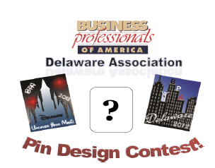

Design the 2018 State Pin

for the
National Leadership Conference!

One design will be chosen by the 2017-2018 State Officer Leadership Team and made into Delaware’s official state pin!

The winning designer will be recognized at the 2018 State Leadership Conference!
Guidelines:

- Any Secondary or Middle Level member (or team) may participate
- Design must use the phrase “Dream Bigger” “Delaware” and “BPA”
- Design should be reflective of the National and State Theme:
“Dream Bigger”
- Must be created using graphics software
- Use colors (4 color max), pictures and/or words.
- BE CREATIVE

DEADLINE: NOVEMBER 6, 2017
ADVISORS EMAIL: elawrence@delawarebpa.org
Students: All submissions must come through your Chapter Advisor

Business Professionals of America, Delaware Association, reserves the right to alter the winning pin as needed.

