Judges - Chapter Advisers Written Submission Instructions

Chapter Advisers logon will be their Chapter ID and Password that they use to logon to the National Membership system
The Chapter Advisers Written Submission URL Secondary:
http://judgesfull.registermychapter.com/org/slcsecondary/conf/s-state
The Chapter Advisers Written Submission URL Middle:
http://judgesfull.registermychapter.com/org/slcmiddle/conf/m-state

Chapter Advisers Login Screen:

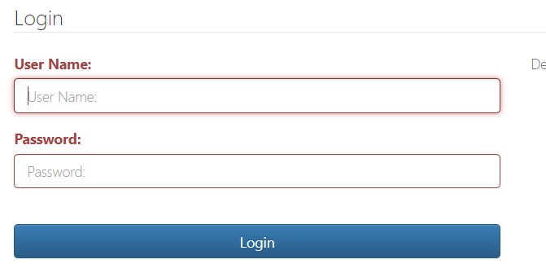
Type the Chapter ID in the Username field
Type the chapter adviser membership password in the password field
Click on the Login button

Click on the Projects button
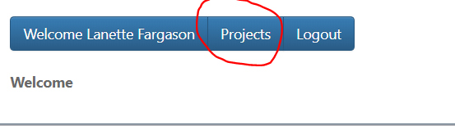
Click on the Submit New Project button
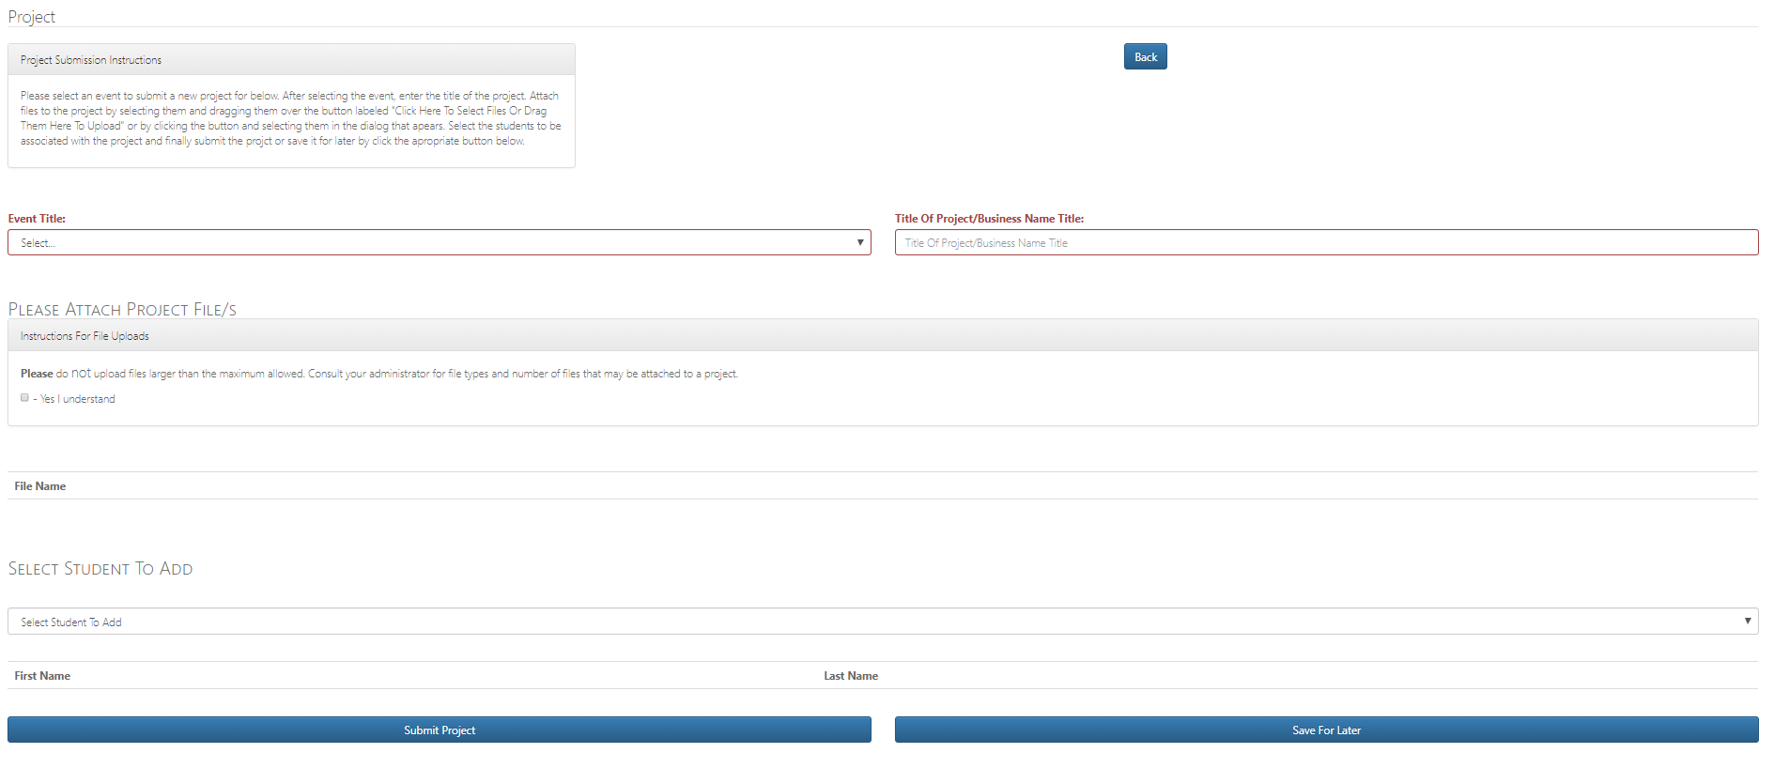
Click on the down arrow located on the right-hand side of the Event Title field
Select the appropriate Event from the drop down list
Type the appropriate Title of Project in the Title of Project/Business Name Title field
Click the Yes I understand check box
Click on the Click Here to Select Files or Drag them Here to Upload button
Select the appropriate Project File
Click on the down arrow located on the right-hand side of Select Student To Add field
Click on the appropriate Student Name from the Drop Down List (If multiple students, repeat selecting)
Click on the Save for Later button if you do Not want to submit the project now and want to submit later OR Click on the Submit Project button if you are ready to Submit the Project
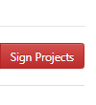
Once you submit a project or multiple projects, the Sign Projects button will appear in the upper right hand corner of the page. You Must click on this button to sign the statement of assurance for the Projects or the project is not fully submitted. Note: If you submit several projects and click on this button, it will attach the statement of assurance to all the projects submitted in that group. If you submit additional projects, you will need to repeat this process again each time.
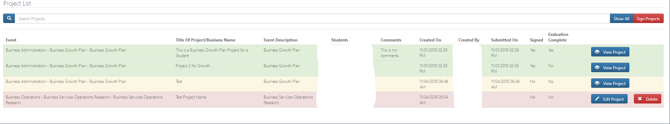

Search Projects – This option allows you to search for a specific project in your list. You can search by Event Name, Title, Event Description and Student Name.
View Project – This will allow you to view the project after the project has been submitted
Edit Project - This will allow you to edit the project prior to submission. This button will only appear if the project has not been submitted
Delete Project – This will allow you to delete the project if it is has not been submitted. This button will only appear if the project has not been submitted.
If you have a submitted project that needs to be changed, you will have to contact the State Adviser/System Admin to release the project back to you. Once this is done, the Edit project and delete button will appear on your screen again.

Click on the Logout button to logout of the system

