BPA Secondary Level Online State Conference Registration
Local Advisor Instructions
Step 1. In your web browser, navigate to https://www.registermychapter.com/bpa/de.
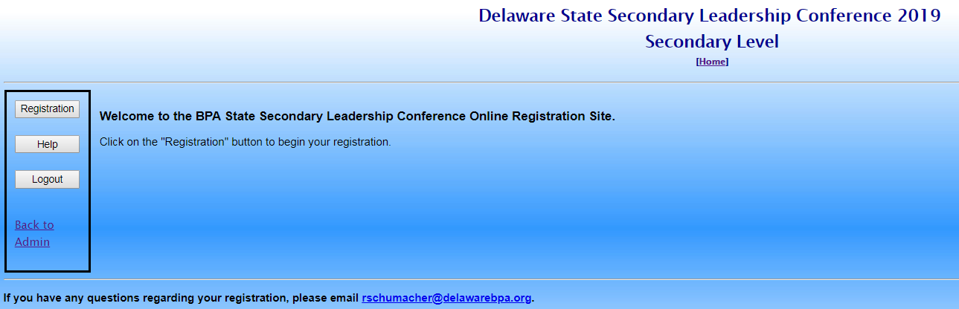

Step 2. Click the Registration button on the left. Then type in your Username [chapter ID number] and your Password. Click Login.
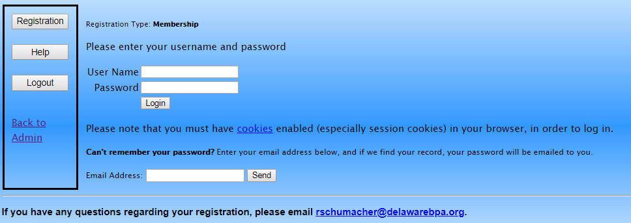

Step 3. You will be asked to update your advisor information. Then you will be able to complete your registration. You can start your registration, save it and finish later by clicking the Save and Finish Later link. Click the View Registration button to preview the registration before submitting.
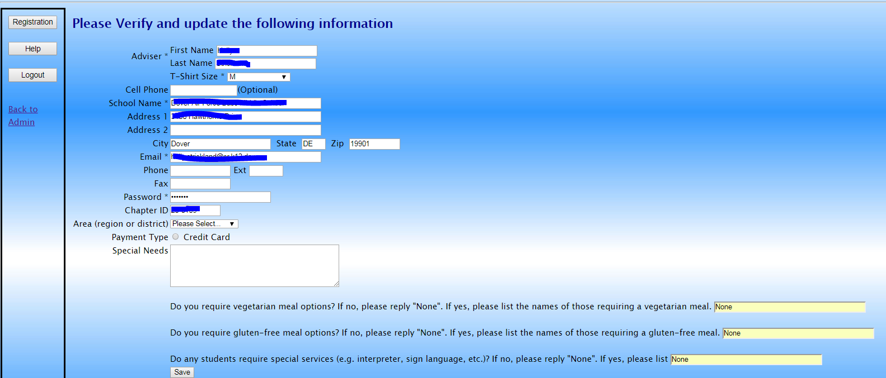
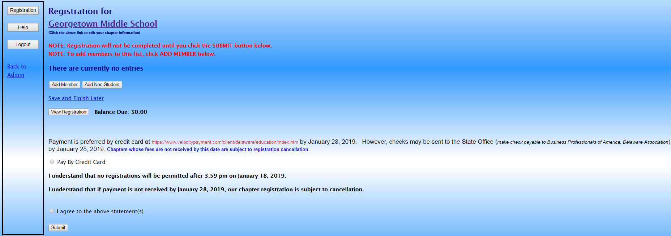

Step 4. To add members, click the Add Member button. Remember – students must be national members to register for SLC. Then select members from the existing list and choose the events for the selected member.
Step 5. To add additional chaperones and guests, click the Add Non-Student button and enter the appropriate information.

NOTES:
- Credit card is the required method of payment.
- You must agree to the two statements shown on the registration page before submitting.
- The student to adult ratio is 10:1. You must have the correct number of adults to submit your registration.
- Contact Robert Schumacher at rschumacher@delawarebpa.org if you have any questions.

