Advisor Certification and Sign-Off
Due by January 17, 2020 at 5:00 pm

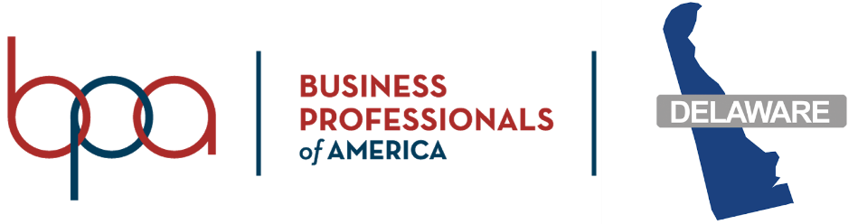

Advisor Verification and Sign Off

Permission Forms / Dress Code / Code of Conduct / Photo Release

I certify that the following forms have been reviewed and/or completed for each student attending the 2020 Business Professionals of America State Leadership Conference.

- Parent Permission SLC Form C-1

- BPA Dress Code SLC Form C-2

- BPA Code of Conduct SLC Form D-1

- Parental Authorization for Photo Release SLC Form J-1 (* Please list the student(s) name(s) below if a parent does not grant permission). photo release form

BPA Advisor School

The parent(s)/guardian(s) of the student(s) listed below do not grant permission to the Delaware Department of Education to use their child’s picture for publication.

Return by January 17, 2020 to: Rob Schumacher
rschumacher@delawarebpa.org

