BPA Virtual Conference
Cisco Webex Meeting Room Instructions
FOR ADVISORS/STUDENTS

- Navigate to nationalbpa.webex.com
- Download the Webex Meetings Client (if you have not already done so).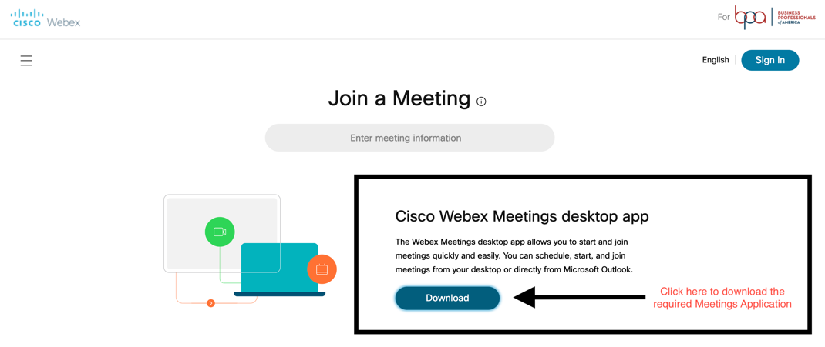
- Once installed, test your connection by navigating to https://www.webex.com/test-meeting.html.

- Enter in your information in the fields and click on the “Join” button to test your connection to a Cisco Webex meeting.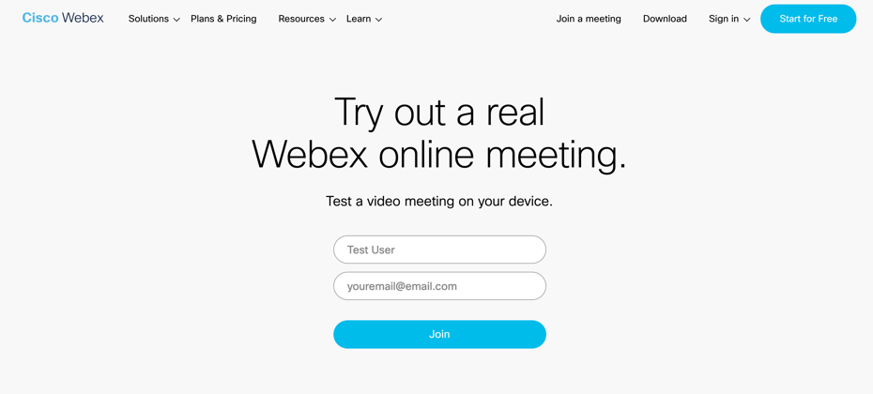

- You will be asked to Open Cisco Webex Start to start the application and connect to the meeting. You also can click “Join from your browser” to join the meeting. This option is recommended if joining from a Chromebook.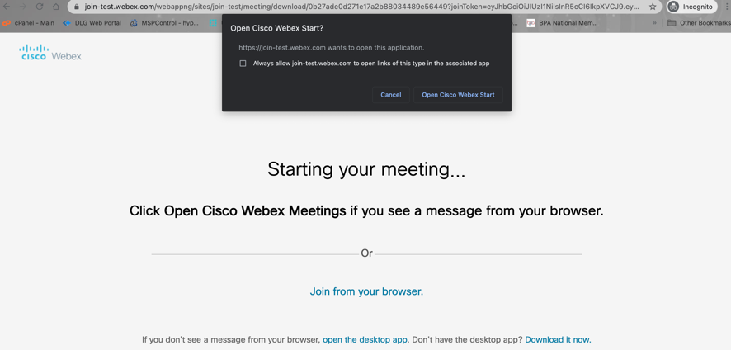
- Once the application loads, you should see a screen similar to the following: 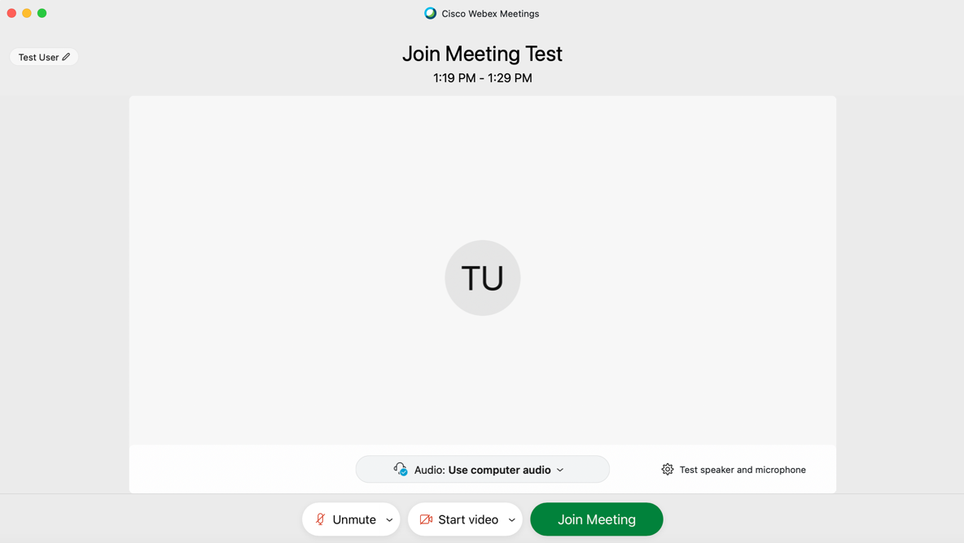

- You can now test your audio and camera by click on the buttons below. When you are ready to enter the meeting, please click on “Join Meeting”.

