BPA Virtual Conference
Cisco Webex Meeting Room Instructions
FOR JUDGES/PROCTORS

- Navigate to nationalbpa.webex.com
- Download the Webex Meetings Client (if you have not already done so).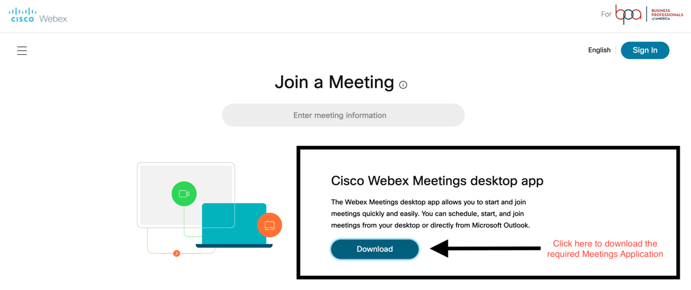
- Click the “Sign In” button. 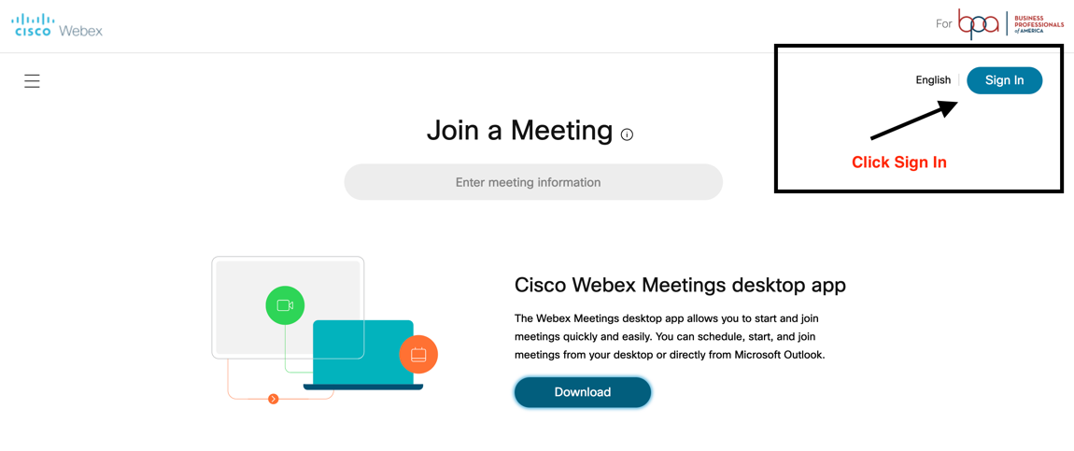
- Login in with the username/password provided to you
- You will be redirected to log in with Microsoft Single Sign On (SSO). 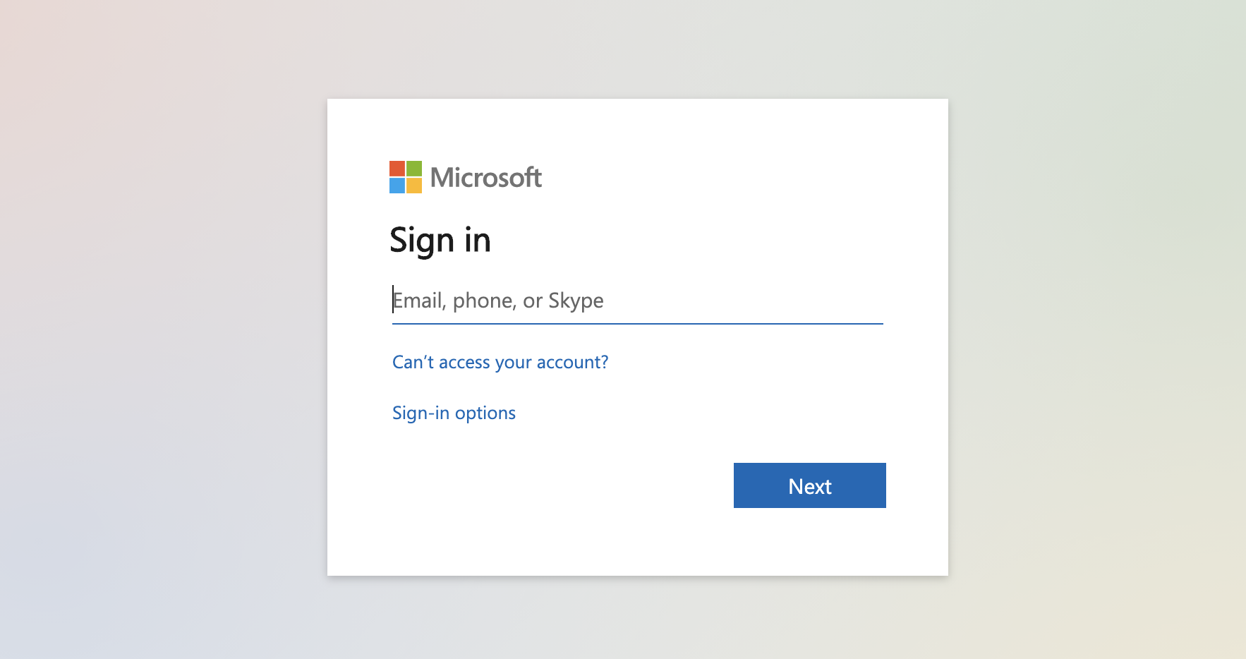
- Once logged in, you will see the following screen of details. Click on “Start Meeting” to start your personal BPA event meeting room.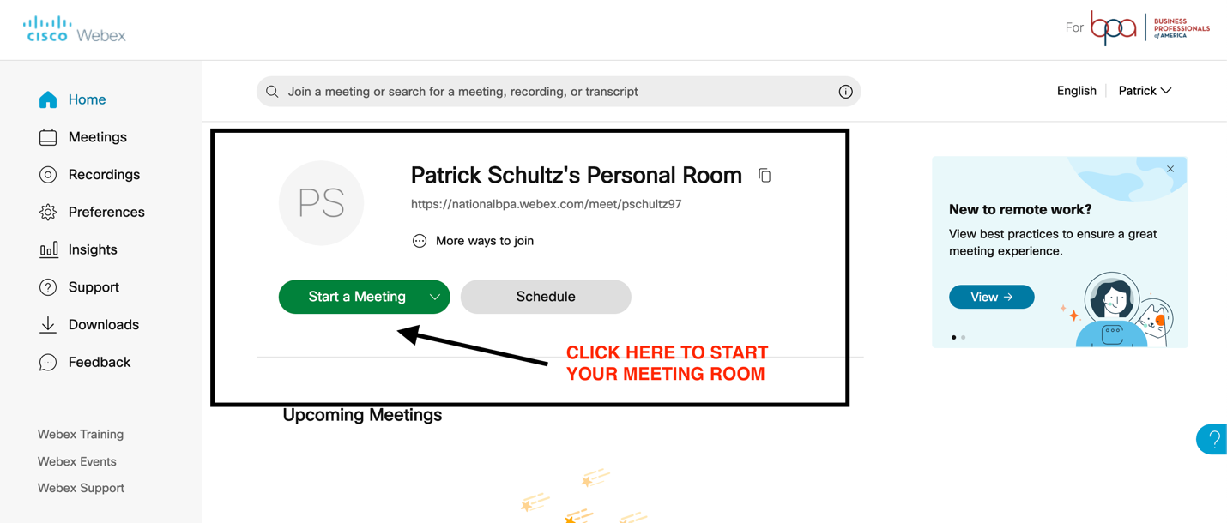
- As the main host of the Webex room, you control who can enter the room by default. The purpose of this is to ensure that competitors (individual or teams) are not entering the room before their scheduled time or during another competitor’s presentation.

- Once in the room, you will have the ability to use breakout rooms (if you will be using them in your Region).
Step 1: Webex Breakout Rooms
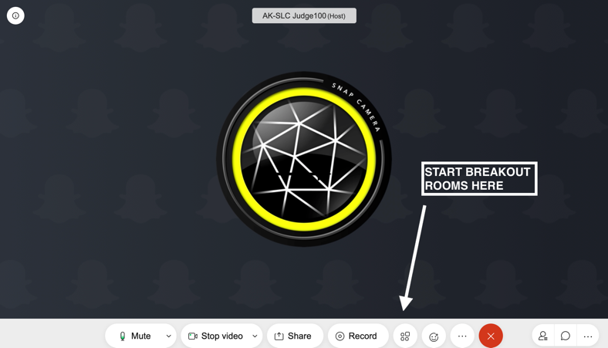

Step 2: Webex Breakout Rooms

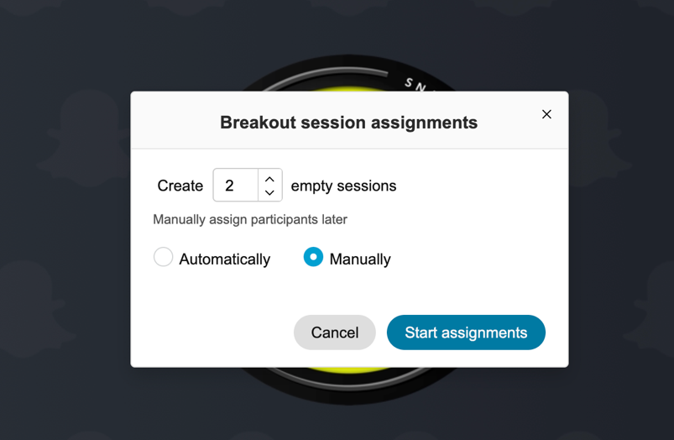

Step 3: Webex Breakout Rooms

