BPA Middle Level Online State Conference Registration
Local Advisor Instructions
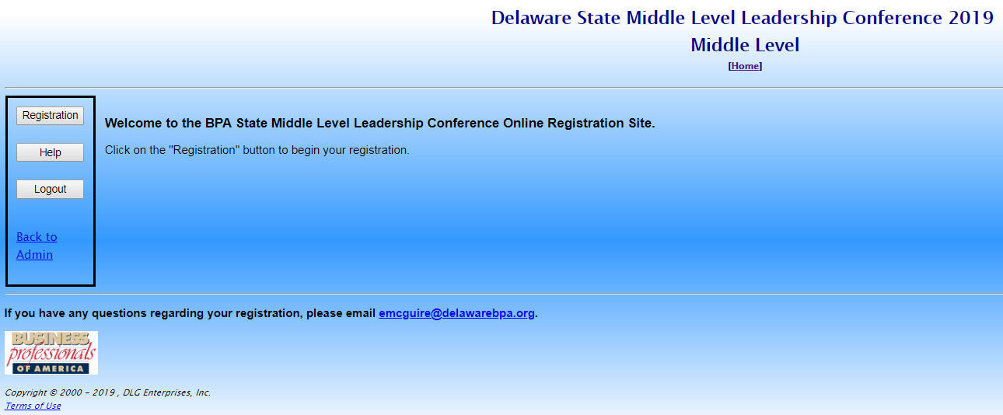
Step 1. In your web browser, navigate to https://www.registermychapter.com/bpa/de-ml.

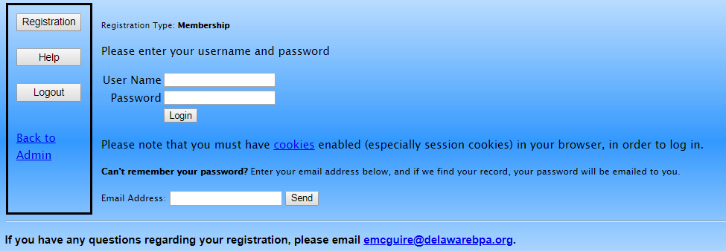
Step 2. Click the Registration button on the left. Then type in your Username [chapter ID number] and your Password. Click Login.

Step 3. You will be asked to update your advisor information. Then you will be able to complete your registration. You can start your registration, save it and finish later by clicking the Save and Finish Later link. Click the View Registration button to preview the registration before submitting.

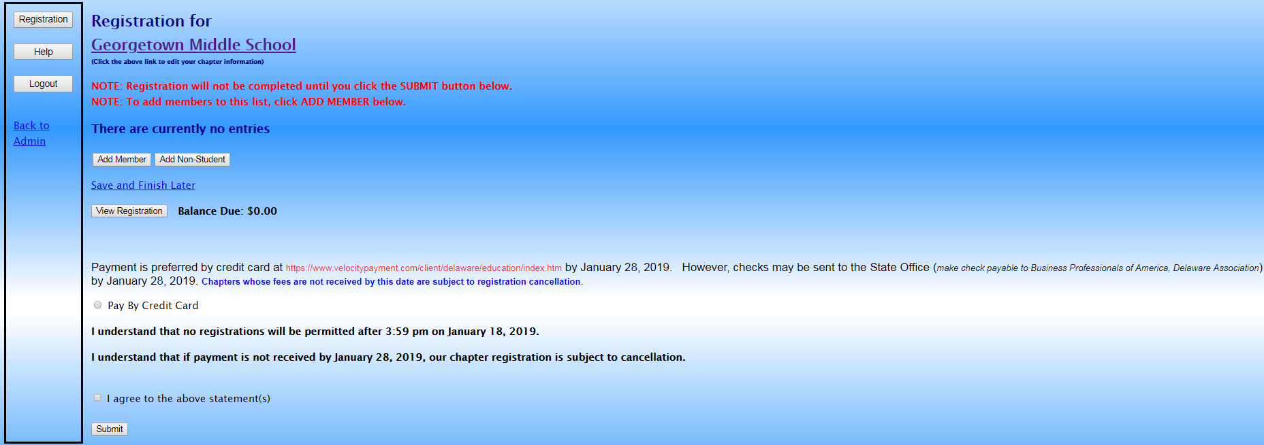
NOTES:
- Credit card is the required method of payment.
- You must agree to the two statements shown on the registration page before submitting.
- Contact Eric McGuire at emcguire@delawarebpa.org if you have any questions.

